REACT ASSIGNMENTS
Assignment 12:
Aim: To create a React application named Blogger Application that displays Books, Blogs and Courses using multiple React components.
Implementation:
1. Create a react app ticketbookingapp
Command: npx create-react-app ticketbookingapp
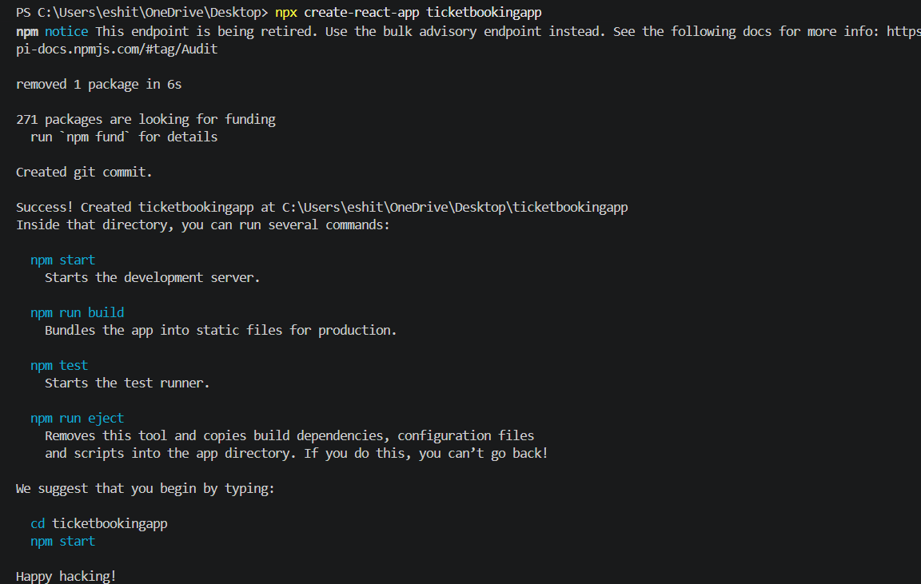
2. Navigate to the Project Folder
Move into the project directory.
3: Start the React Development Server
Run the following command to start the application.
npm start
4. App.js
import './App.css';
import BookDetails from './BookDetails';
import BlogDetails from './BlogDetails';
import CourseDetails from './CourseDetails';

function App() {

return (

<div className="container">

<BookDetails />

<BlogDetails />

<CourseDetails />

</div>

);

}

export default App;

5. App.cs
body {
margin: 0;
padding: 30px;
font-family: Arial;
background: #f2f2f2;
}

.container {
display: flex;
justify-content: center;
gap: 20px;
align-items: flex-start;
flex-wrap: wrap;
}

.container > div {
background: white;
width: 300px;
min-height: 300px;
padding: 20px;
border-radius: 10px;
box-shadow: 0 0 10px rgba(0, 0, 0, 0.2);
}

h2 {
text-align: center;
color: #0b5394;
}

h3 {
margin-bottom: 5px;
}

p {
margin-top: 0;
margin-bottom: 15px;
}
6. BookDetails.js
import React from "react";

function BookDetails() {

const showBooks = true;

const books = [
{
id: 1,
title: "Master React",
price: 670
},
{
id: 2,
title: "Deep Dive into Angular 11",
price: 800
},
{
id: 3,
title: "Mongo Essentials",
price: 450
}
];

return (

<div>

<h2>Book Details</h2>

{
showBooks &&
books.map(book => (

<div key={book.id}>

<h3>{book.title}</h3>

<p>Price : ₹{book.price}</p>

</div>

))
}

</div>

);

}

export default BookDetails;
7. BlogDetails.js
import React from "react";

function BlogDetails() {

const showBlogs = true;

const blogs = [
{
id: 1,
title: "React Learning",
author: "John"
},
{
id: 2,
title: "Installation Guide",
author: "Smith"
}
];

return (

<div>

<h2>Blog Details</h2>

{
showBlogs
?
blogs.map(blog => (

<div key={blog.id}>

<h3>{blog.title}</h3>

<p>Author : {blog.author}</p>

</div>

))
:
<p>No Blogs Available</p>
}

</div>

);

}

export default BlogDetails;
8. CourseDetails.js
import React from "react";

function CourseDetails() {

const showCourses = true;

const courses = [
{
id: 1,
name: "React",
duration: "2 Months"
},
{
id: 2,
name: "Angular",
duration: "3 Months"
}
];

if (showCourses) {

return (

<div>

<h2>Course Details</h2>

{
courses.map(course => (

<div key={course.id}>

<h3>{course.name}</h3>

<p>Duration : {course.duration}</p>

</div>

))
}

</div>

);

}
else {

return (

<h3>No Courses Available</h3>

);

}

}

export default CourseDetails;
9. Output:
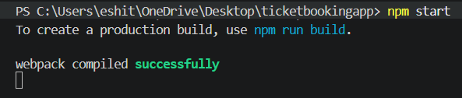
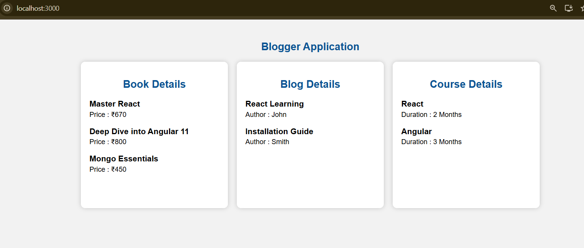
10. Result
The Blogger Application was successfully developed using React components. The application displays Books, Blogs and Courses in separate reusable components with a responsive card layout. The output was verified successfully.

